**To fetch hosts from the respective host groups based on their operating system.**

**STEP-1:** Log in to Dynatrace,and in the left-side filter menu, search for **"Data Explorer"** under **Observer and Explore.** Click on it to open the corresponding page.

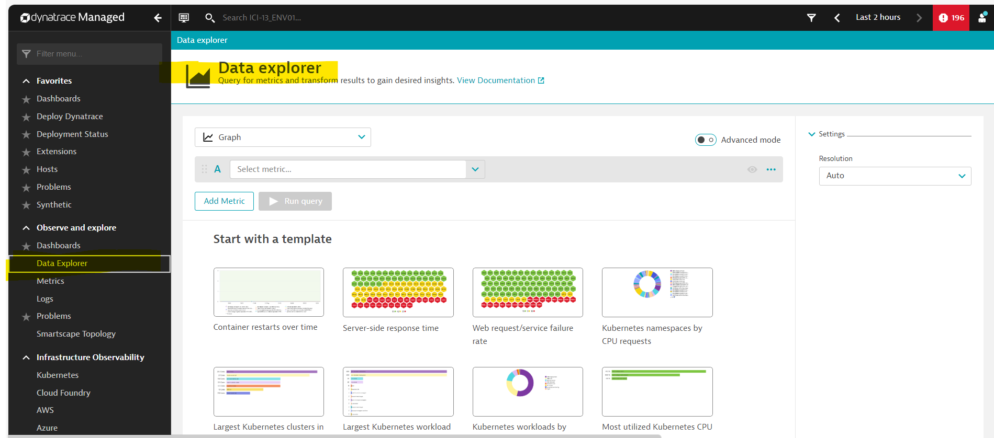

**STEP-2:** Click on the drop-down and select **Table** as shown below.

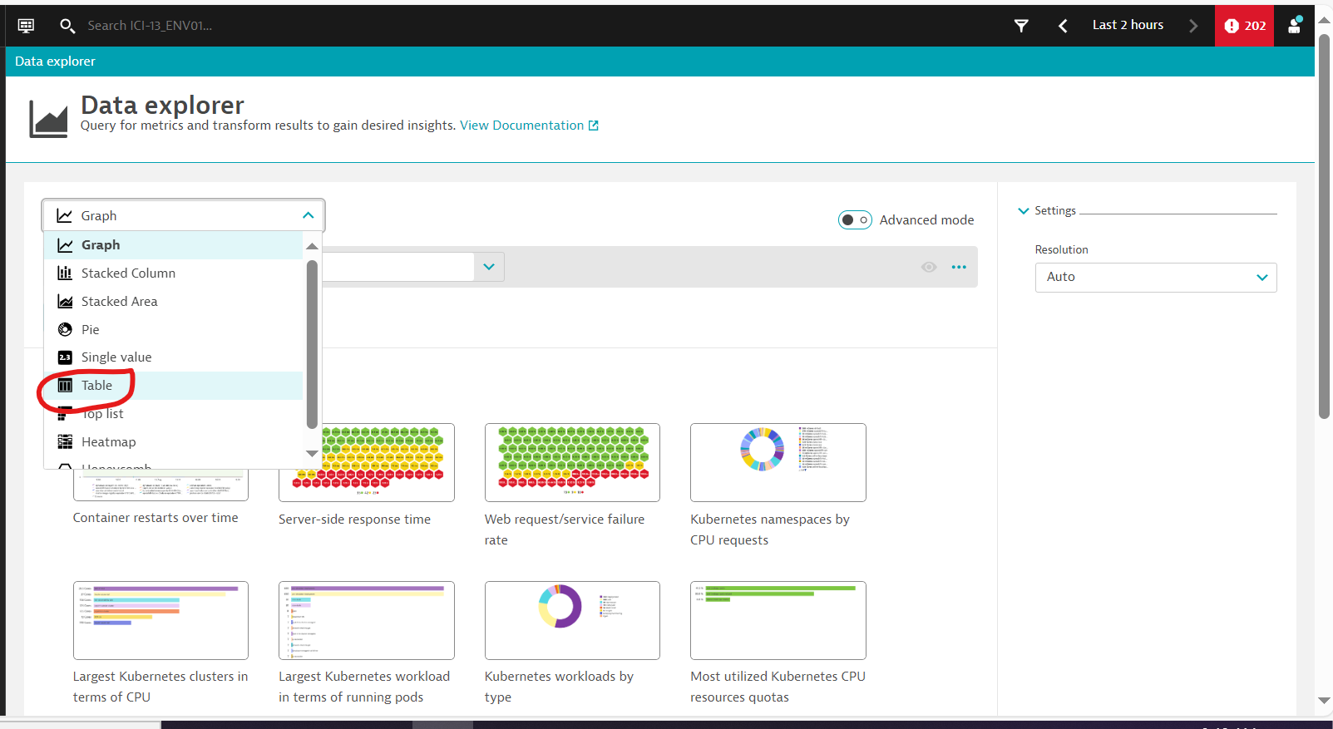

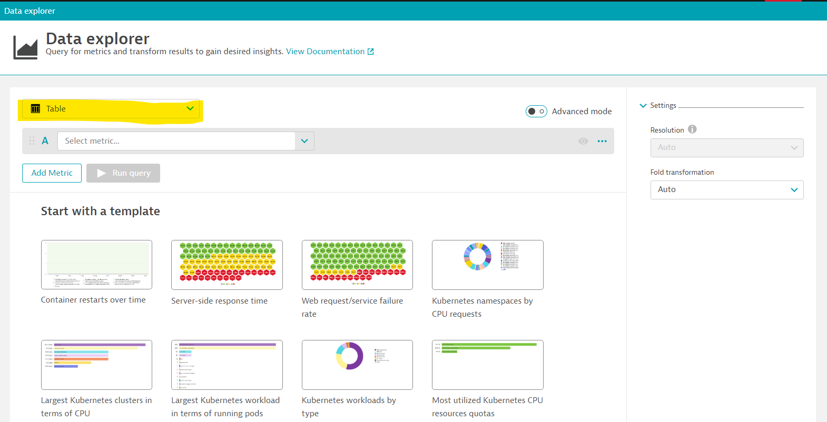

**STEP-3:** Turn on the **Advanced mode** toggle on the right side as shown below.

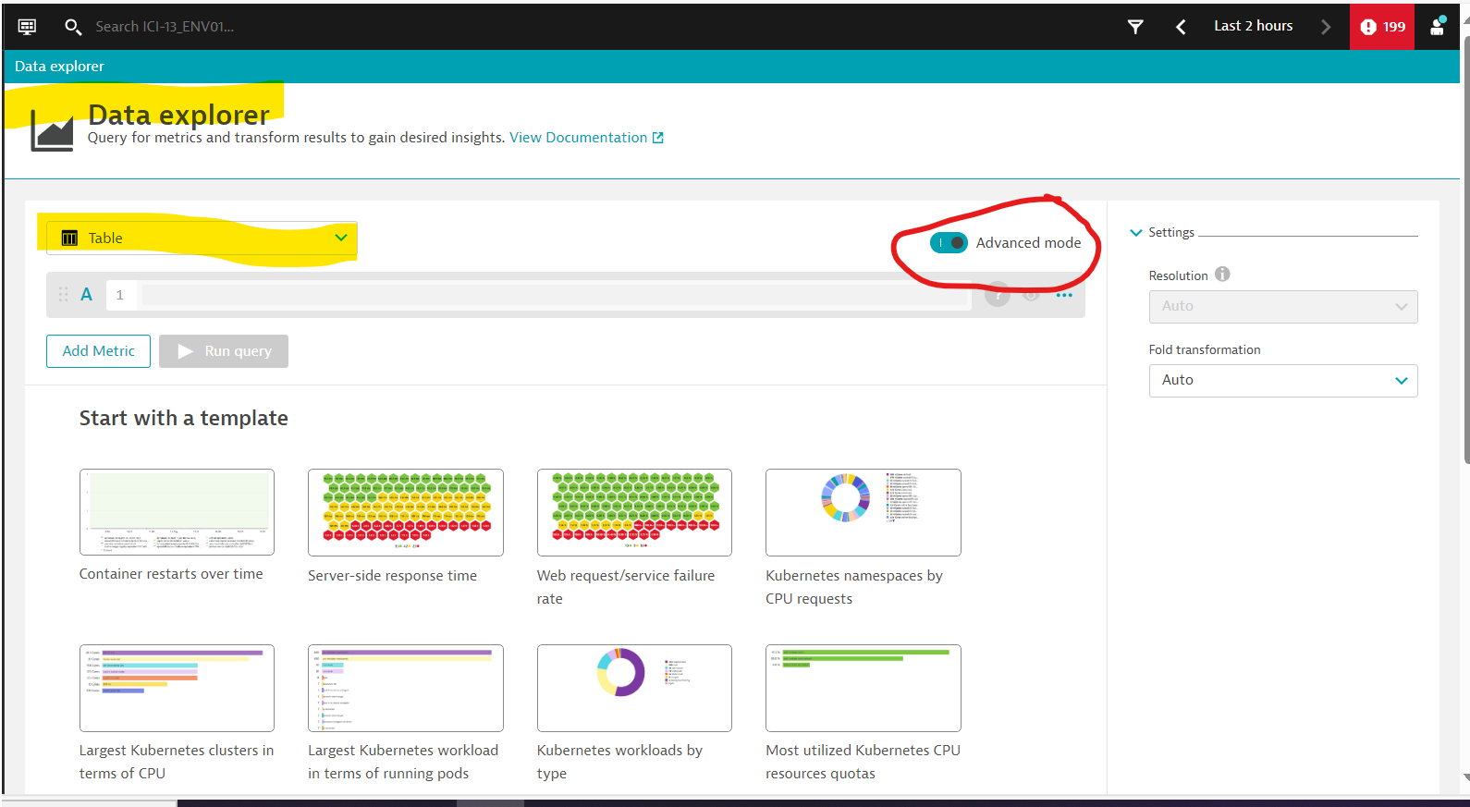

STEP-4: Paste the below query as shown below:

**builtin:host.availability:filter(and(or(in("dt.entity.host",entitySelector("type(host),fromRelationship.isInstanceOf(type(HOST_GROUP),entityName.equals(~"DEVELOPMENT~"))"))),or(in("dt.entity.host",entitySelector("type(host),osType(~"LINUX~")"))))):splitBy("dt.entity.host"):sort(value(auto,descending))**

**NOTE:-**

If you need a report for **Host group = "TEST"** and **OS = "WINDOWS"**, update the query as follows:

* Replace entityName.equals(~"DEVELOPMENT~") with entityName.equals(~"TEST~").
* Replace osType(~"LINUX~") with osType(~"WINDOWS~").

Run the updated query after making these changes.

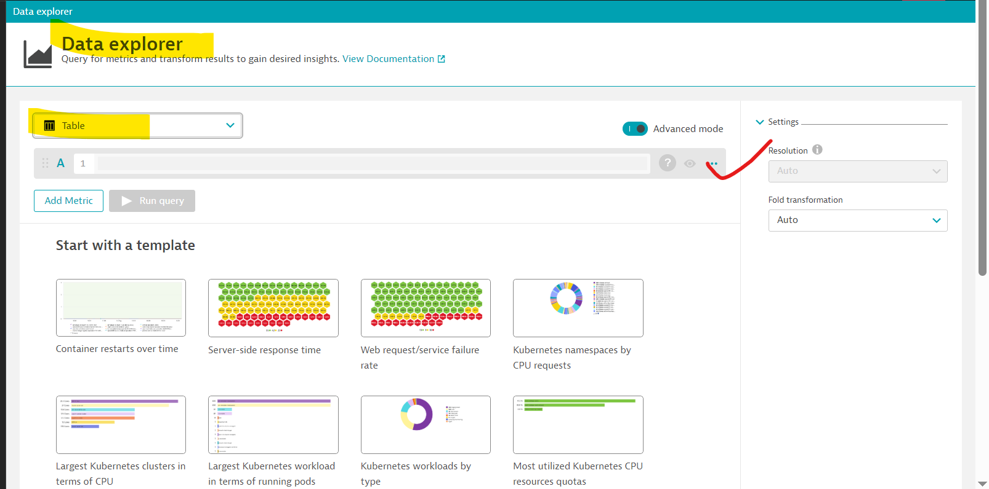

**STEP-5:** Click on **Run query** it will fetch the required details as shown below.

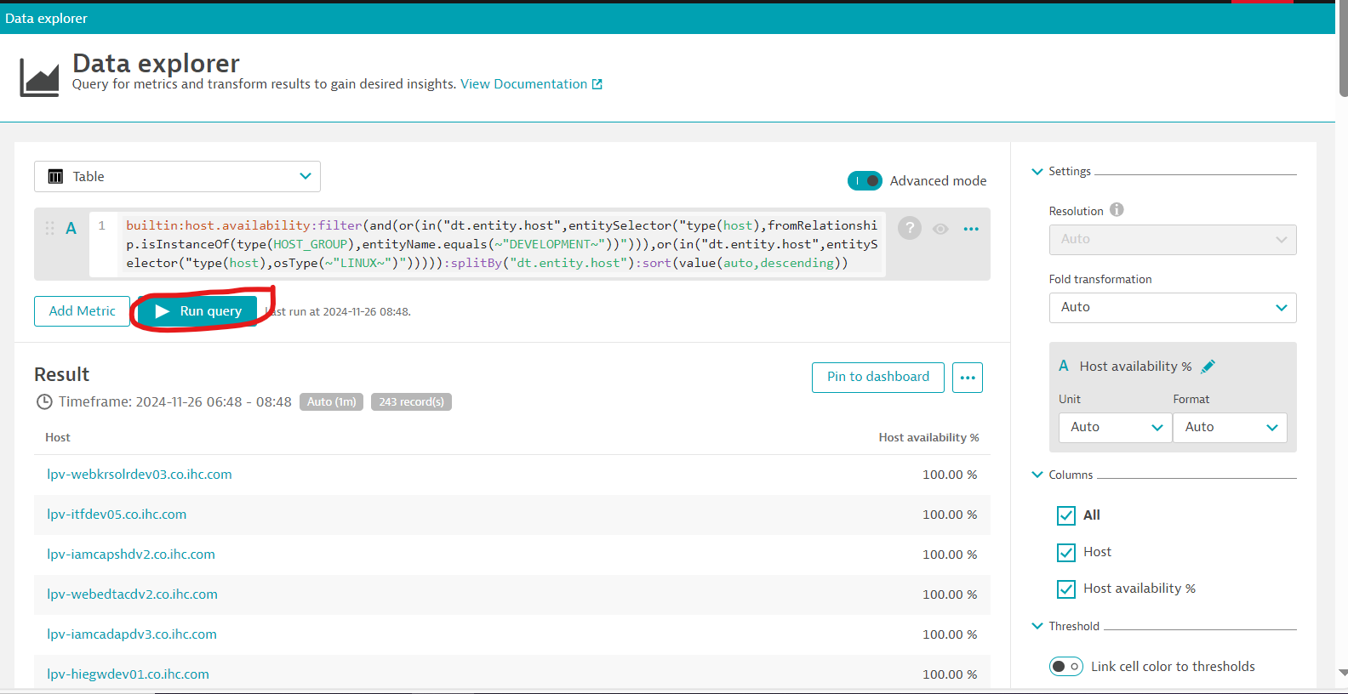

**STEP-6:** To export the report to **.csv ,** follow the below process.

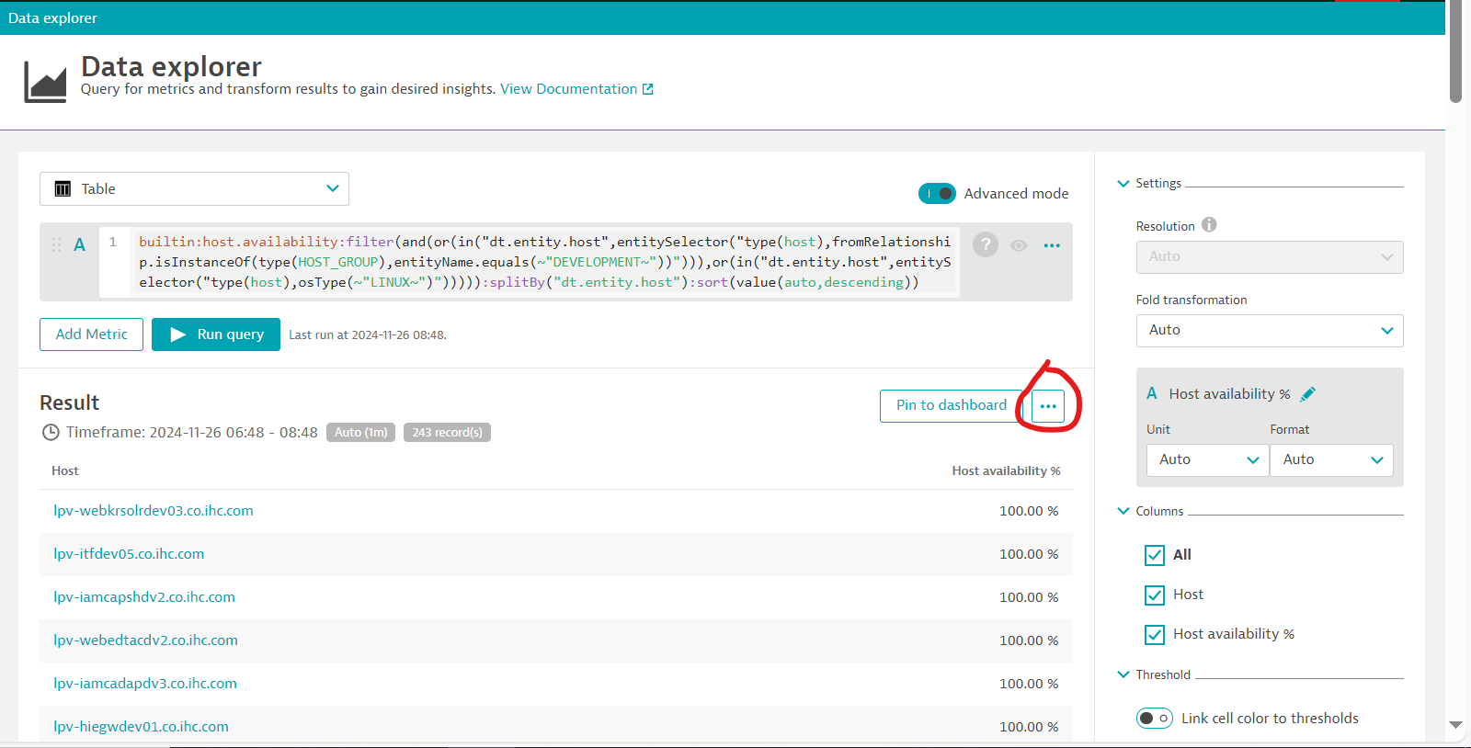

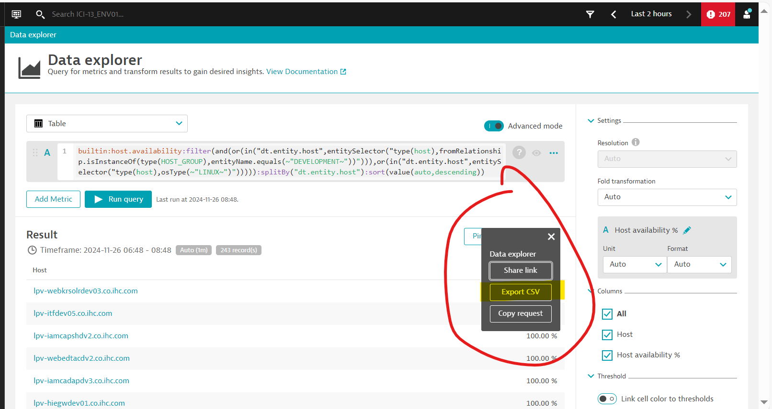

**STEP-7:** When you click on **Export CSV**, a Host report will be automatically generated and downloaded.

